CSULB ACM
Augmented eBay
Empower your eBay listing with rich multimedia, files and intertwine with social media for less
Karan Bhandari, Jarrod Dickerson, Vipul Chopra, Varun Chopra ,Saied
10/16/2011

-

Contents
Charter 1

Modified Charter

• Project Manager – Karan Bhandari
Project Definition – This web/mobile application will enable eBay sellers to list items with rich text pictures, videos and files for free.
• Project Scope – Two applications
o Augmented eBay
o Augmented eBay Pro: access to device I/O and file manager (marked by *)

It empowers the seller to upload eBay listings with the aid of following features.
- Rich text description
- Ability to append more than 1 image (upto 20 or more*)for free by the following means
  - Image Url
  - Laptop / Phone /Tablet Gallery
  - Camera *
- Ability to append multiple videos
  - Upload *
  - Youtube URL
  - Laptop / Phone /Tablet Gallery
- Ability to upload files
  - Windows Skydive URL
  - Upload *
- Ability to select background themes and layout.
- Ability to tweet as soon as item is listed
- Gain visibility on Youtube

• Project Goals – Stepping stone towards Innovation Challenge and eventually own company.
• Project Dependencies – Sencha, ASP.NET, PhoneGap, C#.NET 4.0 and server (kurtzace.com)
• Project Team – Karan Bhandari, Varun Chopra, Vipul Chopra , Saied Farivar and Jarrod Dickerson.
• Project Stakeholders –
- One mentor chosen by the board of College of Engineering Innovation challenge committee.
- Ebay
• Project Phases –
o Acceptance into eBay developer’s program.
o Construction of Application.
o Scrutiny by eBay
o Deploy to mobile marketplace
• Project Timeline – By the end of the semester

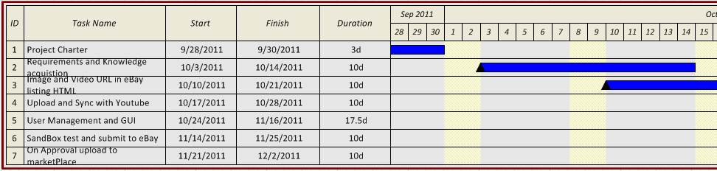

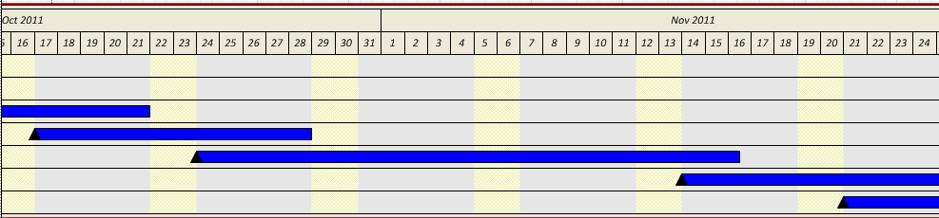
• Project Challenges – Once the application is constructed, it has to pass the eBay screening program.
• Project Finances – None.
• Project Estimated Completion Time – ~140hours.
• Project Status – We have server space in kurtzace.com, we are accepted into eBay developer’s program, commenced application construction.
• Project Contact(s) – Karan Bhandari, +1 302 438 2953.
Karan.bhandari@student.csulb.edu

